**Wolf Head Geometric Wall Mount**

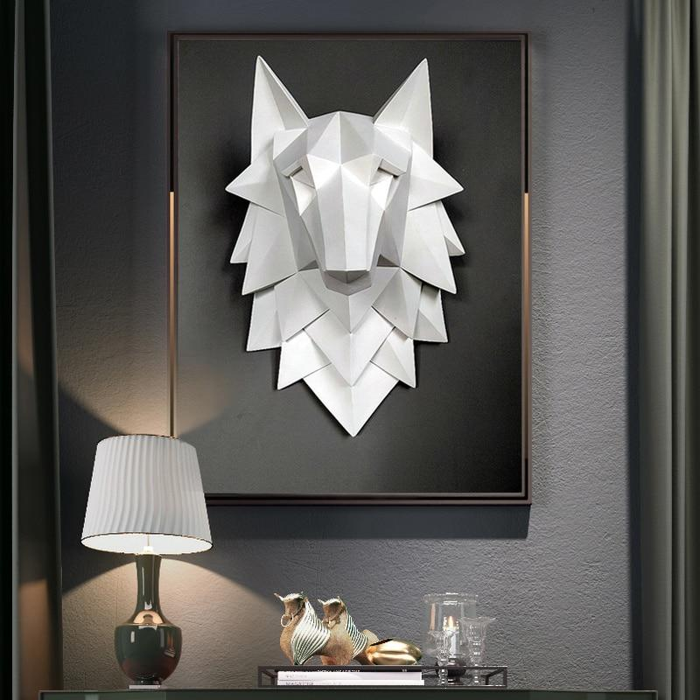A wolf head geometric wall mount is a bold and artistic decor piece that combines the raw power of nature with sleek modern design. Crafted with clean, angular lines to form a 3D geometric representation of a wolf's head, this wall mount exudes strength and sophistication. Often made from materials like metal, wood, or resin, it comes in a variety of finishes, such as matte black, metallic tones, or natural wood, to complement diverse interior styles. Perfect for a living room, study, or office, this striking decor item symbolizes courage, leadership, and a connection to the wild, making it an inspiring focal point.